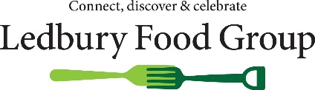
Ledbury Food Group
Our Privacy Statement
A privacy statement explains what information we hold about you, why we hold it, how we protect it for you and how you can have information removed from our files if you wish.
What information do we hold about you?
The information that we hold about you is either:
Basic contact information e.g. your name, email contact and/or phone contact if you are not a member of Ledbury Food Group
Or:
More personal information than above including your address and brief details of your interests relevant to the Food Group if you have consented to be a member of Ledbury Food Group
Why do we hold this information?
We hold this information
- To inform you about local food events and meetings which may be of interest to you
- To inform you about local food issues and topics
- To contact you for assistance in running events or activities
- To inform you and/or seek your views on any issues that impact on our local food economy
And in the case of members, where we hold more information:
- To enable us to communicate effectively with you as a member taking account of the preferences you have expressed to us via your membership form or subsequently
Do we share this information with any other body or person?
It is not our policy to share this information with any other body or person other than the secure data service which processes our database and despatches emails for us. We will not do so without your permission.
How long do we keep your information?
We keep information for as long as we need it for the purposes for which it was collected. If your information changes, please let us know so that we can keep you informed on local food issues.
Your rights
We hope that you welcome the communications that you receive from Ledbury Food Group. You have the right at any time:
- To see copies of the information that we hold about you
- To update the information that we hold about you
- To request that we cease using your information to contact you or for any other purpose
If you wish to do any of these please contact us either by email to ask@ledburyfoodgroup.org or by phone to 01531 633637.
May 2018

If you are still happy to hear from us about News, Promotions and Events, then you do not need to do anything more and we will continue to keep in contact with you.

If you prefer not to hear from us, then please send us an email to the address above letting us know.

