Contact us at 01531 633637
or ask@ledburyfoodgroup.org

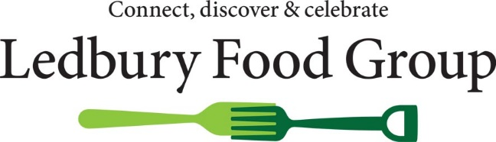
Ledbury Food Group – would you like to help?

We are a group of volunteers passionate about supporting our local farmers, food producers and shops as a means of sustaining a thriving market town at the heart of this exceptional farming area.

We would like to welcome some new members to join our management team and help to maintain the Group’s activity. Currently the team is small (just five individual members supported by a producer and two town councillors).

We would also welcome new volunteers willing to become involved in a more general way, for example helping with a particular project or research, or with promotion and marketing including helping to develop the Group’s presence on social media.

Who can help us?
Anyone with an interest in enhancing the life of this vibrant rural district with the traditional market town of Ledbury at its heart. Most likely they will share an interest in enjoying local food and welcome the chance to find out more about the people who grow, produce and offer it for sale. Organisational or administrative skills could be helpful, but curiosity and interest are even more important.

What do we do?
- We raise awareness of the importance of locally produced food and drink for the vitality of our town and surrounding countryside and maintenance of the landscape. Bringing shoppers to Ledbury to buy or consume local food and drink returns benefits to nearby farmers and producers and supports other independent retailers. Local food satisfies consumer demand for sustainability, freshness, seasonality, provenance and quality.

- We arrange public talks on food topics, a book group “Thought for Food”; and projects with local farmers recording “The Farming Year”. We are in the process of organising an evening Farmers’ Market. With more helpers and resources, we could do even more.

- Our website – www.ledburyfoodgroup.org - provides information and blogs about local food matters, a calendar of events and a comprehensive directory featuring details of local food and drink producers.

- Our special events bring local food producers to, and support retailers in, Ledbury. Our food fair, the Ledbury Celebration, brings the best of local producers to a grand market in Ledbury town centre each July, and our Ledbury Big Breakfast in January celebrates local produce through our independent cafes, hotels and shops.

How do we do it?
Monthly “business” meetings, kept as brief as possible (1.5 hrs), cover planning for current activities and events. From time to time we review the group’s general direction and policies. We are a constituted community group and have a small reserve of funds for events/projects.

None of our committee members started with experience of this sort of group – we pool our knowledge and support each other to develop new skills.

