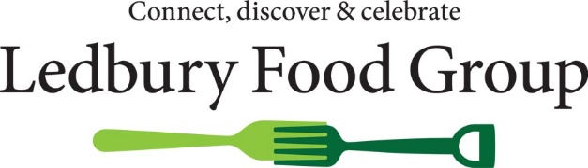
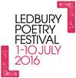

Booking is now open for the
Ledbury Food & Drink Festival, part of the Ledbury Celebration 2016 – food, drink, poetry & music
Sunday 10 July 2016
11.00am until 6.00pm
Once again we are delighted to invite you to join us at the Ledbury Celebration, a festival of food, drink, poetry and music organised jointly by Ledbury Food Group and Ledbury Poetry Festival.
Venue
Like last year, the 2016 Festival will be held in Orme & Slade’s car park, just off the High Street and the adjacent Bye Street Car Park.
Orme & Slade’s car park will be covered by a Temporary Event Notice which allows immediate consumption of alcoholic drinks within this car park area (which will be stewarded). Off sales will also be allowed.
Food stalls will be in the Bye Street Car Park which will also have an area for festival visitors to sit and eat, drink or just pass the time. We are exploring with the local authority whether we can extend consumption of alcoholic drinks to this car park as well.
With this arrangement, it will be possible to close the food area earlier than the drinks area in the light of business on the day, as in previous years.
Live entertainment
There will be live poetry and music in the drinks area in Orme & Slade’s car park. The entertainment, continuing until 6.00pm, will encourage people to stay through the day and to buy food, drink or picnic items which they can consume there and then, as well as take home. The Poetry Festival plan to include several entertainments around the site in addition to the poetry and music programme – these were popular last year.
Publicity
Local publicity will be maintained with articles about the food festival in the Ledbury Reporter, Hereford Times and Malvern Gazette. Banners, street signs and locally-distributed flyers will make sure people do not miss it! As the event is being organised in conjunction with Ledbury Poetry Festival, it will be widely promoted by them via their festival brochure, on their website and through their mailing list. The Poetry Festival itself attracts national press publicity. It will also be listed online in the Visit Herefordshire, Food Festival finder and other event websites, and in detail on the Ledbury Food Group website amongst others.
And as an early bird incentive, if you book before 10 April 2016 you will be listed in the advert in the Poetry Festival brochure and on the event flyer.
Stall details
8ft x 4ft stalls with an awning-style roof will be provided. Electricity is available at a small extra cost. Preference will be given to those in Ledbury and the vicinity, but if there is no local producer/manufacturer of a particular item, applications will be accepted from those further afield to ensure a good choice of products. We are looking for a good variety of stalls offering food for immediate consumption as well as to take home.
Charges are held at last year’s prices. There is a charge of £45.00 per stall for food producers and soft drink producers and £50.00 per stall for alcoholic drink producers. If you require electricity there is an additional charge of £15.00 per stall. Payment must be made at the time of booking. Application forms and payment must be received by 14 June 2016.
Ledbury Poetry Festival attracts a large number of visitors to the town, and this promises to be a fun and exciting event. We very much hope that you will be part of it, simply return the accompanying forms to us as soon as possible to ensure a stall.
With best wishes
Katie Bott
Ledbury Food Group
t: 07949 030580 or 01432 890388

e: katiebott@gmail.com
and postal address
Old Orchard Cottage, Yarkhill, Hereford HR1 3TD

